

**FYP Midterm Progress Report**

**E-Ustad**

**Group Members:**

Najeeb Ullah (Eb22210106081)

Raza Muhammad (Eb22210106085)

Muhammad Ishaq (Eb22210106063)

Muhammad Hammad Fayyaz (Eb22210106049)

**Supervisor:**

Dr Farhan Ahmed Siddiqui

**Department, Year/Semester:**

UBIT, 4th/7th

**Executive Summary (Abstract)**

This project is a web-based platform designed to help people in Pakistan find skilled workers easily. Itis focused on local professionals such as electricians, plumbers, gardeners, and other workers. Many people don’t know where to find reliable help for home or office tasks. At the same time, skilled workers often don’t have a proper digital space to show their services. Our website solves both problems. It allows professionals to create profiles and list their skills, and it allows clients to search and contact them directly.

**Introduction**

In today’s world, people want fast and easy solutions. But here in our country, it is still difficult to find skilled workers online. If someone needs an electrician or plumber, they usually ask friends or go out to find one. There is no single, trusted online platform made just for this need. At the same time, many local professionals have skills but don’t know how to reach customers online. Our project aims to build a website where both sides can connect. This platform will help workers grow their business and help clients save time. It’s a simple, modern solution for a common real-life problem.

**Problem Statement**

There is no proper online platform in Pakistan that connects local skilled workers with people who need their services. Most clients don’t know where to find trusted electricians, plumbers, and similar professionals. They waste time looking for someone and still don’t get the right person. On the other hand, skilled workers don’t have a good place to show their services and reach more customers. Social media is not made for this purpose, and other websites are not focused on local workers. Because of this, both sides suffer. A trusted digital solution is missing in the market.

**Objectives**

* To create an easy-to-use website that connects local workers with clients.
* To help skilled professionals list their services and reach more customers.
* To help clients find trusted workers quickly, without leaving their homes.
* To build a platform that supports digital growth of local businesses.
* To provide a simple and secure way for both parties to communicate.
* To make sure that all profiles are verified and safe to use.
* To support the local economy by making local services more reachable.

**Technologies Used**

* + Frontend: HTML, CSS, EJS templating
  + Backend: Node.js + Express.js
  + Database: MongoDB
  + Authentication: Passport.js or JWT (mention whichever you're using)
  + Deployment Plan (Heroku/Vercel/Render later?)
  + Git/GitHub used for version control?

### **Functional Modules**

#### **User Authentication (✔️ Completed 90%)**

The authentication module allows users to securely register and log in to the platform using their email and password.

* **Signup/Login:**  
  Users can create an account or log in using their email credentials through dedicated forms on the platform.
* **Password Hashing:**  
  Passwords are hashed using **bcrypt** before being stored in the database, ensuring that raw passwords are never exposed.
* **Session Management:**  
  The application uses **JWT (JSON Web Tokens)** to manage sessions, allowing for stateless and scalable authentication.

#### **Profile Creation (✔️ Done 80%)**

The profile creation module enables users to maintain personal details based on their role—Client or Professional.

* **Professionals:**  
  Professional users have an extended profile structure that includes:
  + **Skills/Profession Selection**
  + **City/Address**
  + **CNIC Picture**
* **Clients:**  
  Client users maintain a basic profile with:
  + **Full Name**
  + **Email**
  + **Phone Number**
  + **Address**
  + **Profile Picture**

This separation ensures relevant data collection based on the user type and enhances the personalization of the platform

* **Service Listing (⏳ Partial)**

The service listing module allows professionals to showcase their available services on the platform.

* **Professionals:**  
  Can select and list their profession from predefined categories such as plumber, electrician, carpenter, etc., during signup or profile update.
* **Browsing/Filtering:**  
  Basic browsing functionality is available. Filtering and advanced search options are planned for future development to improve user experience and discoverability.

#### **Dashboard (⏳ In Progress / Planned)**

The dashboard feature is designed to provide a personalized experience for both clients and professionals.

* **Professional Dashboard:**  
  Will allow professionals to:
  + Manage and update their service listings
  + Edit profile details
  + View incoming service requests (planned)
* **Client Dashboard:**  
  Will help clients to:
  + View recently visited professional profiles
  + Save/bookmark preferred professionals
  + Track service history (planned)

This module is currently under development and will enhance usability and engagement once completed.

#### **UI/UX Design**

* Landing Page  
  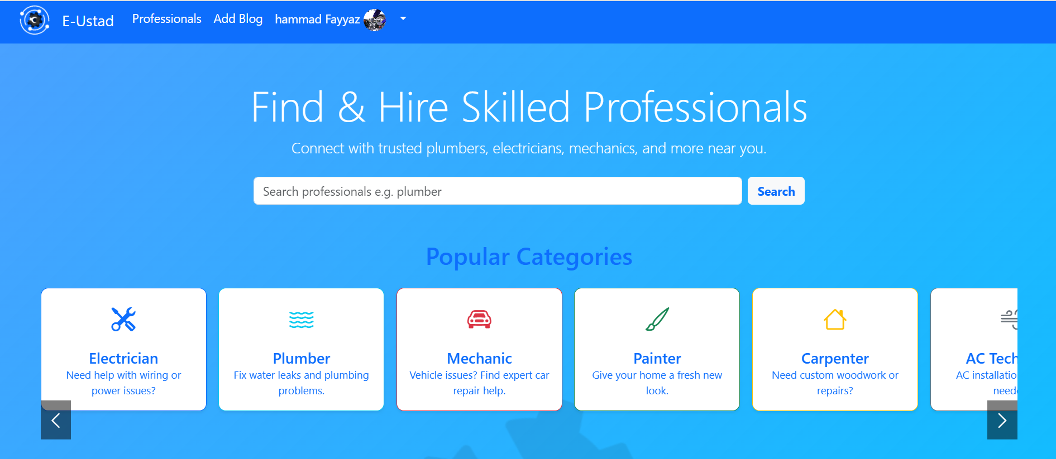

Profile Creation

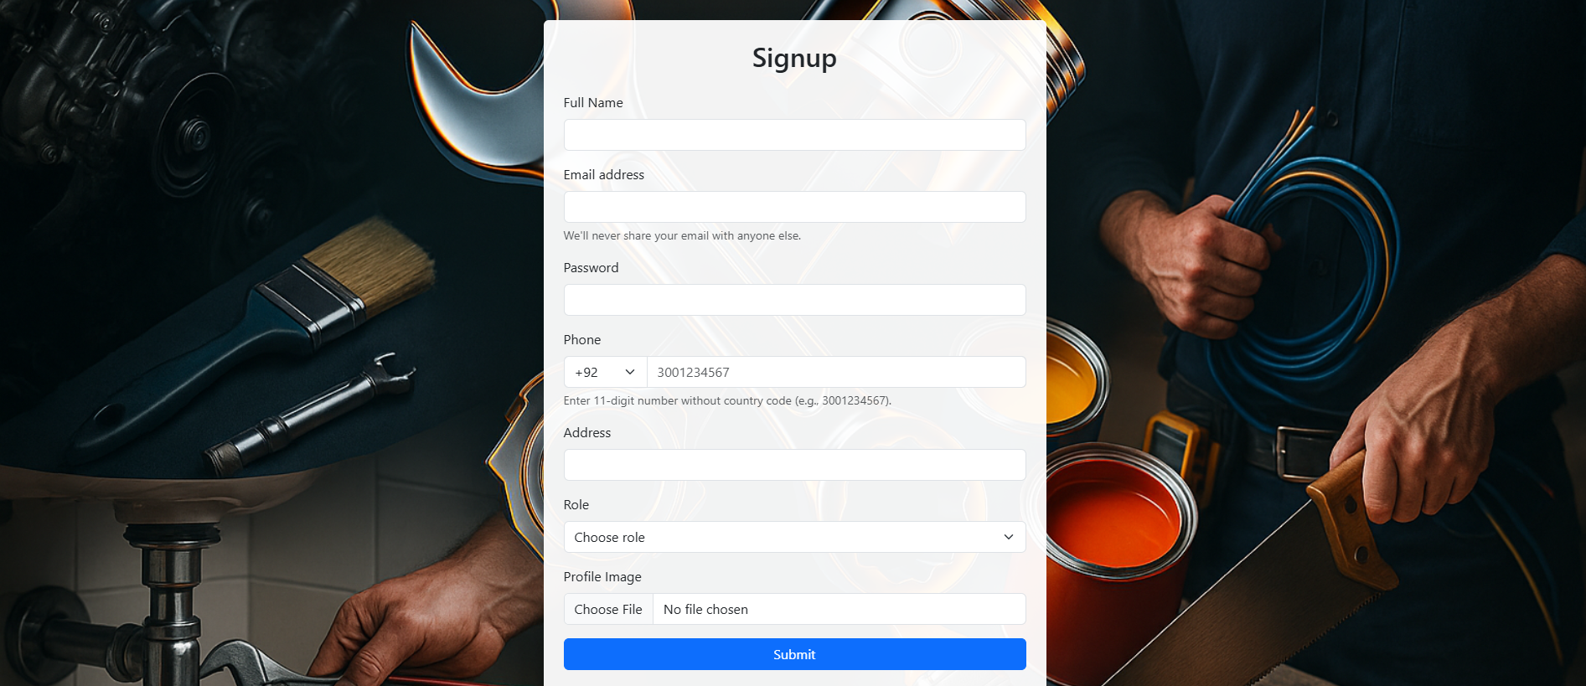

* Login

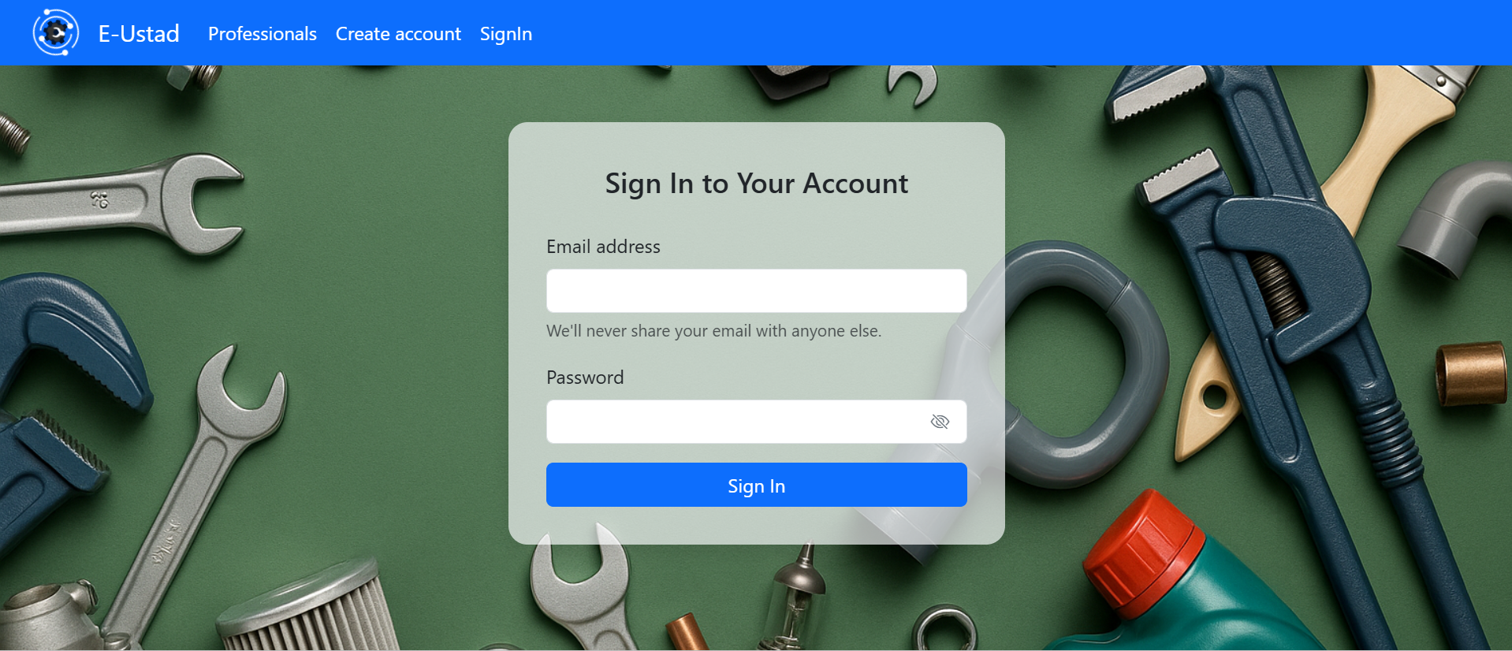

* Listings  
  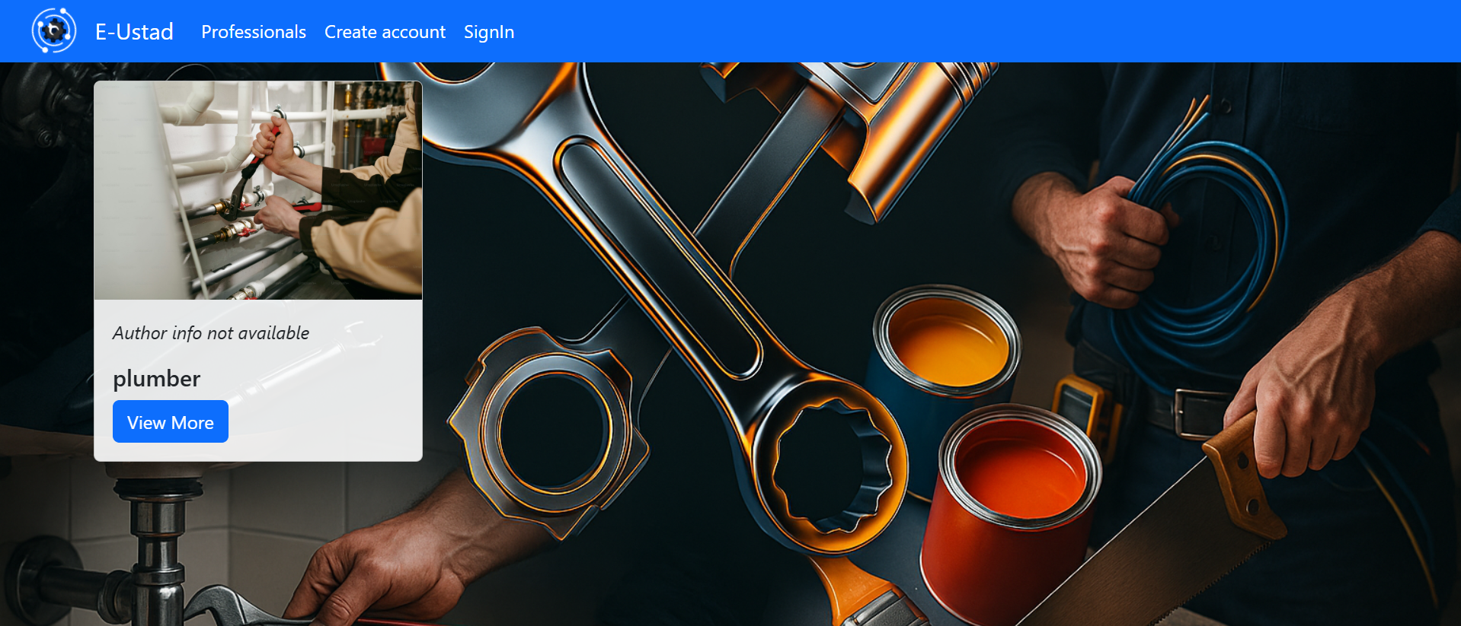

#### **Database Design**

#### Schemas Designed on MongoDB.

* + Users
  + Blogs
  + Comments

X --------------------------------------------------- X --------------------------------------------------- X